IOT BASED SMART HOME

# AIM: IOT Based Smart Home Using Cisco Packet Tracer

# REQUIREMENTS:

Smart devices (home appliances)

Home gateway –which is the main functioning of the smart home

# PROCEDURE:

1. Choose your first smart device. ...
2. Choose your smart home platform. ...
3. Connect more devices. ...
4. Create routines and automations.

IoT home automation is the process of **controlling home appliances automatically using various control system techniques**. The electrical and electronic appliances in the home such as windows, refrigerators, fans, lights, fire alarms, kitchen timers, etc. can be controlled using various control techniques.

Choose the type of home automation solution. ...

Decide on your development strategy. ...

Create user scenarios. ...

Describe the core features of your solution. ...

List all devices your system should support. ...

Choose the right type of data storage. ...

Develop a security strategy.

IMPLEMENTATION:

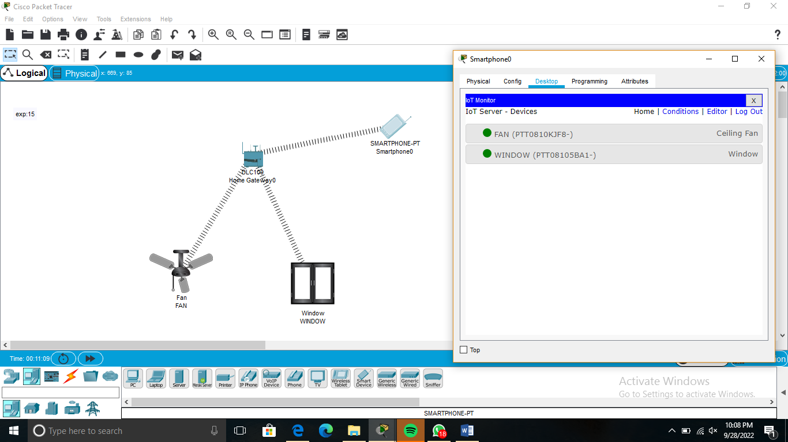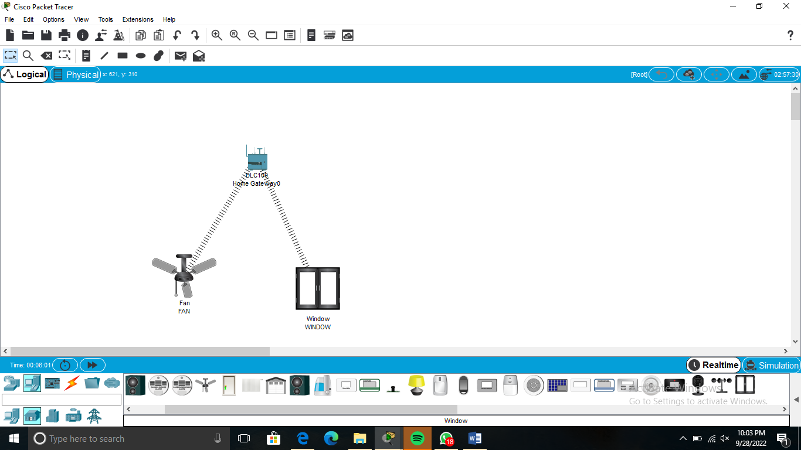

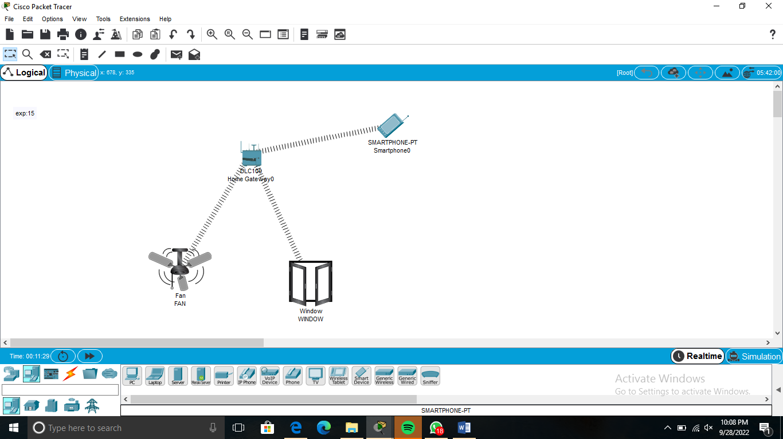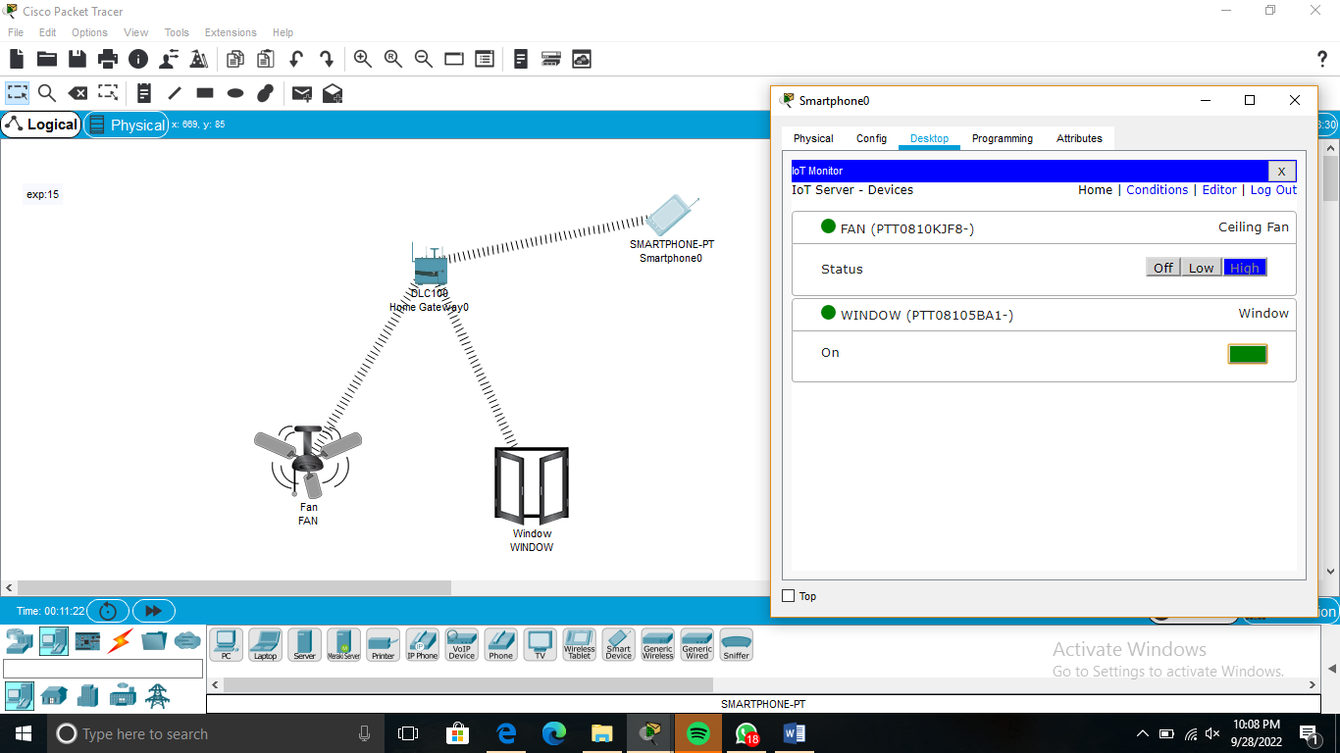

# RESULT:

Hence<A smart home's devices are **connected with each other and can be accessed through one central point—a smartphone, tablet, laptop, or game console**. Door locks, televisions, thermostats, home monitors, cameras, lights, and even appliances such as the refrigerator can be controlled through one home automation system.